|  |  |  |  |
| --- | --- | --- | --- |
|  | Imagine Communications  25 Dyas Rd, North York, ON M3B 1V7  +1 866-446-2446 www.imaginecommunications.com |  |  |
| TEST status report | | | |
| Product summary | | | |
|  | | | |

|  |  |  |
| --- | --- | --- |
| device under test id | TEST name | test version |
| test | IOX-SAN-2U-CORE Test | 1.0 |

|  |  |  |  |  |  |  |  |  |  |  |  |  |
| --- | --- | --- | --- | --- | --- | --- | --- | --- | --- | --- | --- | --- |
| |  |  |  | | --- | --- | --- | | tester | test date | test duration | | default | 2021-09-21 15:42:41.476000 | 506534 | | Test description | | | | A Stock | | |  Status Summary |
|  |
| Test OUTcome |
| ABORTED |

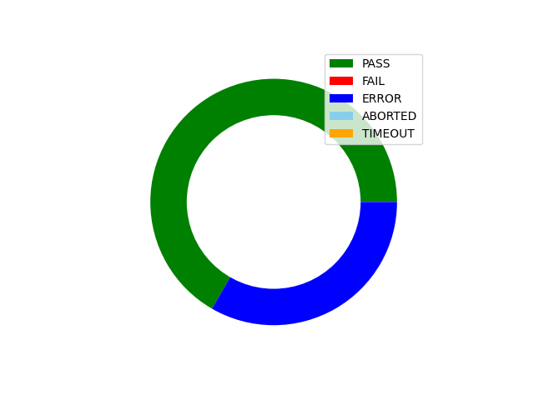

|  |
| --- |
| TEST overview |
|  |

|  |  |  |  |  |  |  |
| --- | --- | --- | --- | --- | --- | --- |
| phase | PHASE name | OUTCOME | test duration | Notes | | |
| **1** | **IOX-SAN-2U-CORE Drive Health** | **PASS** | **333403** | | **None** | | |
| **2** | **Run Info** | **PASS** | **16** | | **None** | | |
| **3** | **UUT Setup** | **ERROR** | **506492** | | **None** | | |

|  |
| --- |
| Test Phase results |
|  |

|  |  |  |  |
| --- | --- | --- | --- |
| phase name | outcome | measurement | Measured VALUE |
| **Run Info** | **PASS** | **Disk Quantity** | **12** |
| **Run Info** | **PASS** | **Disk Part Number** | **IOX-SAN-2U-6TB** |
| **Run Info** | **PASS** | **Part Number** | **IOX-SAN-2U-CORE** |
| **Run Info** | **PASS** | **Customer** | **None** |
| **Run Info** | **PASS** | **Purchase Order** | **None** |